Step 7: Tasks

1. Provide a screenshot of invoking the figlet function (10 pts)

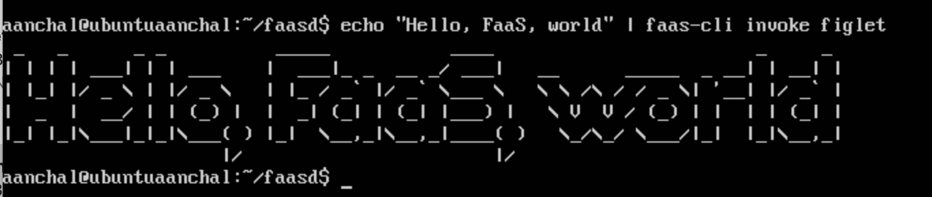

1. Complete slack-request/handler.py (20 pt)

* File added to github

1. Complete slack-interactive/handler.py (20 pt)

* File added to github

1. Provide a screenshot of running the following command (10 pts)

sudo journalctl -u faasd --lines 40

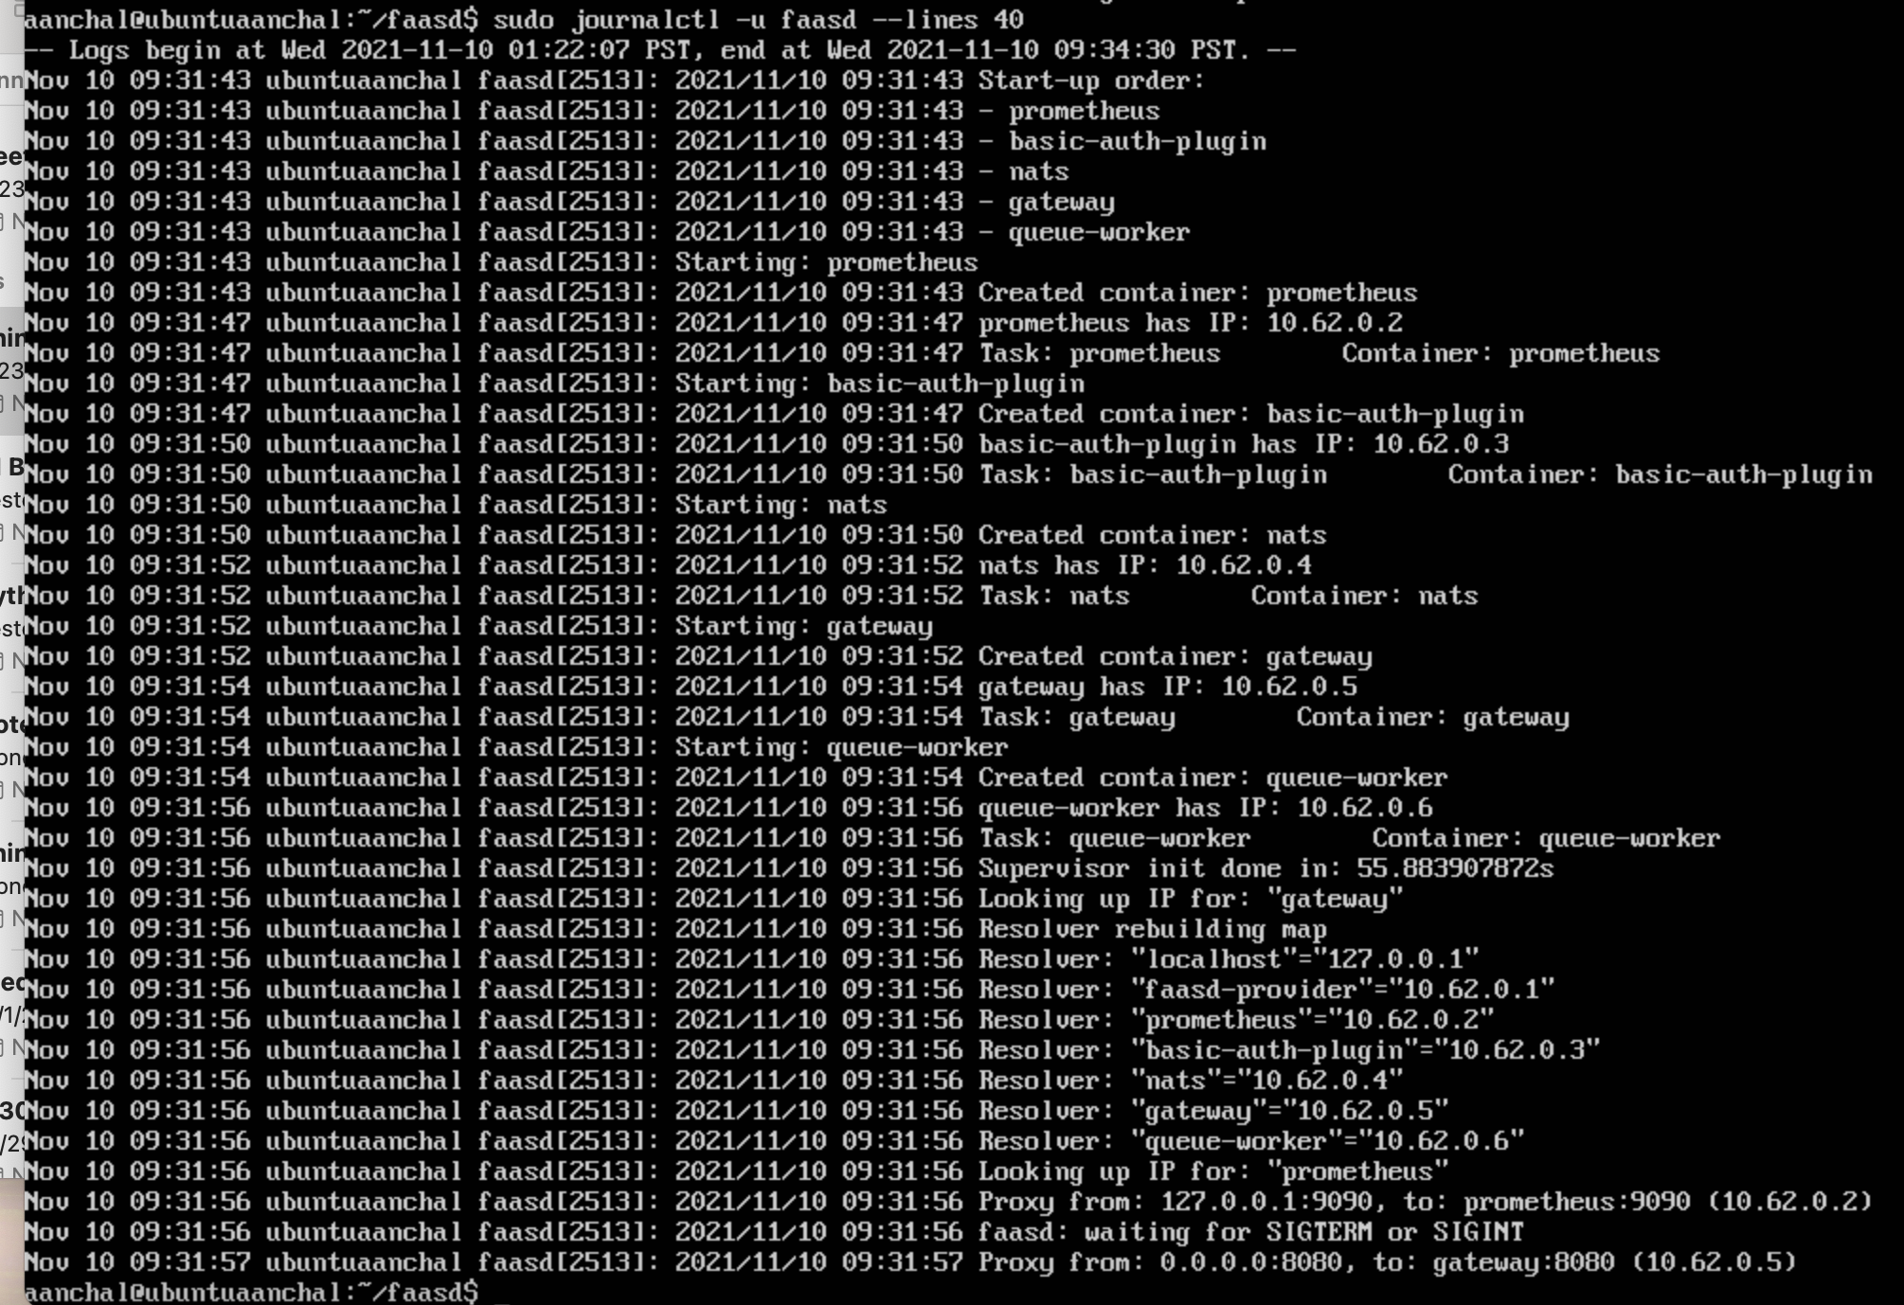

5. Provide a screenshot of your OpenFaaS gateway AFTER deploying figlet, slack-handler and slack-interactive functions (10 pts)

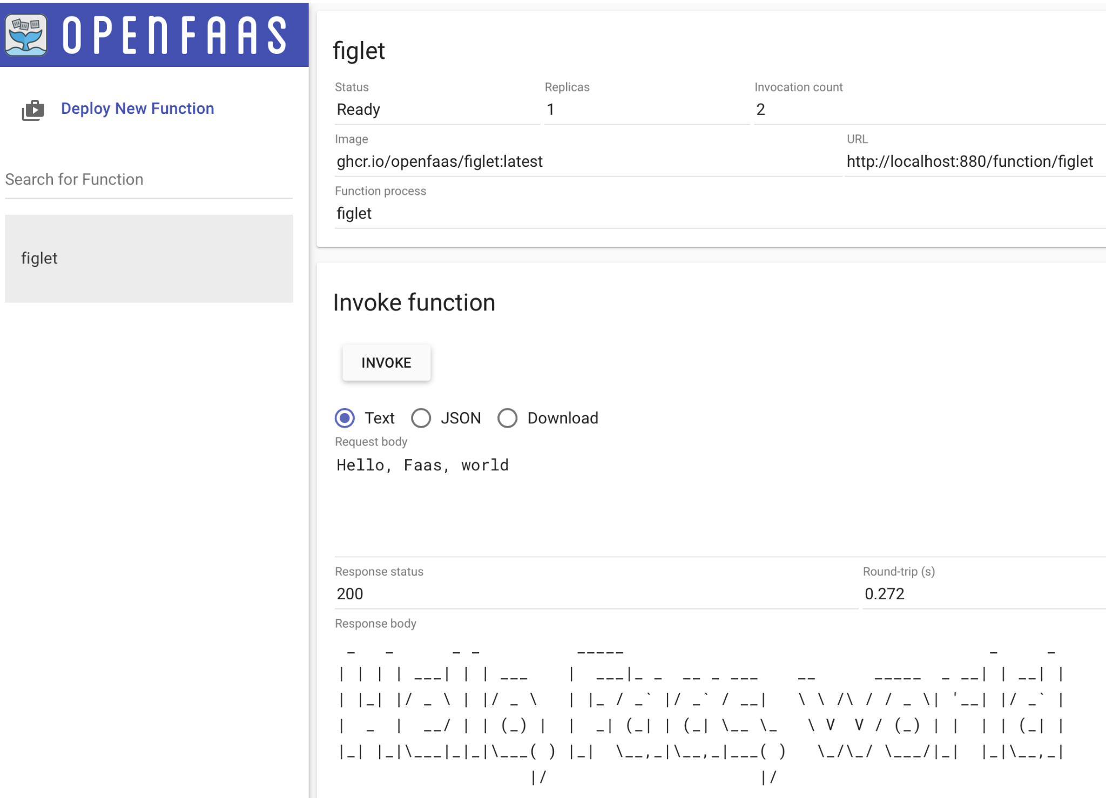

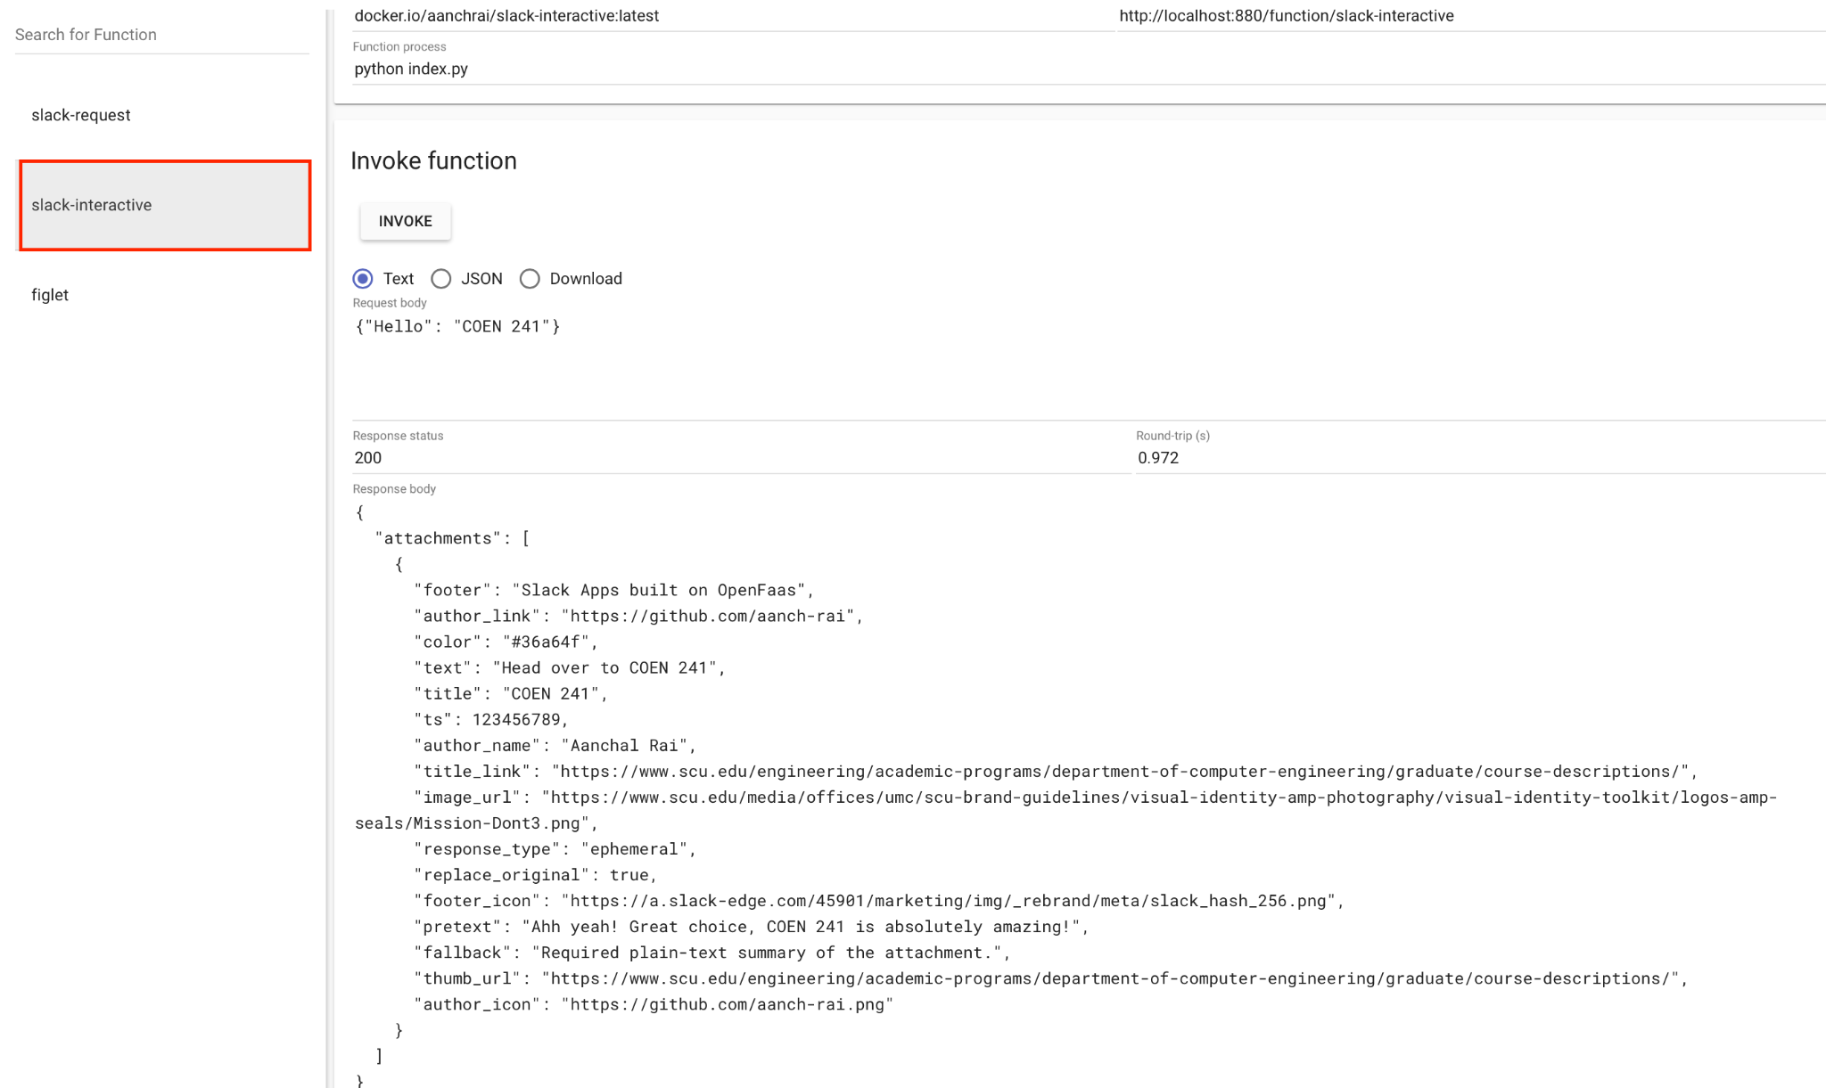

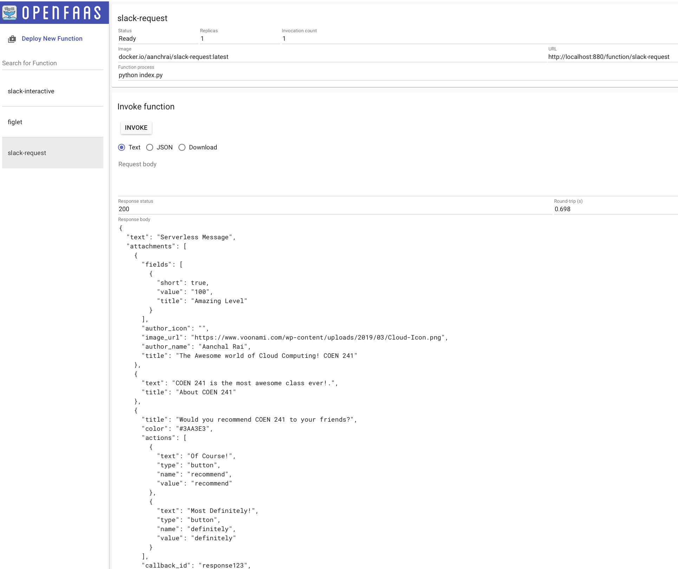

6. Provide a screenshot of invoking slack-request and slack-interactive functions (10 pts)

